

**How one agent got Appointments with 3 Employers…each having over 300 employees**

**Seeing is believing, right ?**

**Is**

**Is it hard to get a hold of Prospects ?**

If so, shouldn’t our process have us PREPARED to improve the odds of achieving an Appointment in ONE phone call when possible….. VERSUS calling back/chasing.

=================================================================================

**Evidence Binder Phone Dialogue…..**for Appointment setting

When most insurance agents call do they say they can SAVE you Money ?

Do you believe them ?

I know it’s awful, isn’t it…

So L.J. here’s what I am going to do

I’m **NOT** not going to TELL you anything

because you’ve been misled too many times, right ?

Instead I’m going to PROVE it to you.

Are you sitting at your Computer ? (have your jpegs queued up and send when they initially answer)

I just sent you Pictures… actual PROOF – Evidence

of customers of ours celebrating – who volunteered to show you their Savings

…so you could know it was true.

Because if somebody can honestly SAVE you – your Boss and your Company –

a pile of money – that would be somebody you’d actually want to invite to your office, right ?

Which one did you open first ?

How Happy would your Boss be if you helped your Company save that much money ?

(Let them talk)

Let them see themself becoming a HERO

What time do you have on your schedule next week ?

RULE: always put their 1st name at beginning of the Subject line

If you are leaving a message on Voice Mail – using the PERMISSION script -

see a different set of Instructions

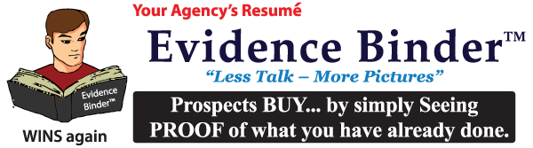

To learn more call L.J. at 805-402-1134